



Technical Specification - SAP Development
Account verification in registration page

Document Reference : Account verification in registration page
Version : 001
Author : Mantu Kumar
Date Created : 29-Feb-2016
Document Status : Draft [Draft/Review/Signed Off]

Approval

Approved by | Name | Role | Signature | Date
Process Team Lead
Development Team Lead

Document History

Version | Reason for change | Date | Modified by
1.0 | Initial draft of technical spec | 29-Feb-2016 | Mantu Kumar
1.1
1.2
1.3

Table of Contents

1. General Information 4
2 Description and Purpose 5
3 Assumptions 5
4 Issues 5
5 Technical Solution 6
5.1 Flow Diagram 6
5.2 Pseudo code 7
5.3 BADI/Enhancement Description 9
6 Custom Tables/Structure in SAP 9
7 Error Handling 10
8 Error Messages 10
9 Security Requirements/ Authorization Details 10
10 Unit Test Plan 10

General Information

Functional Design Spec ID:
Report Name/ID:
Report Title:
Implement. Phase
Message Class:
Develop. Class:
Module:
Report Paper Size
Report User/User Group:
Contact Details:
Prepared By |  |  |  | Prep Date:
 | Phone Number:
 | Email Address:
Business/Functional Analyst:
 | Phone Number:
 | Email Address:
Functional Area User Contact:
Primary:
 | Phone Number:
 | Email Address:
Secondary:
 | Phone Number:
 | Email Address:
Run Frequency |  | Languages
Priority: |  | Complexity:
Expected volume:

Transport Information

Version from Document History | Transport Request # | Task # | Object Identifier  (Program ID, Layout Set ID, etc) | Object Type  (Program, Transaction, Layout Set)
1.0 | CRSK900073
1.1 | CRDK900158 | CRDK900160
1.2

Description and Purpose

Allow a user to enter PO Box or street number of provided BUAG (contract account) mailing address during online registration through Mobius.

Reference JIRA Tickets: PRJBWBMBS-5

Assumptions
User knows the contract account and PO Box or Street number of mailing address of the contract account.

Issues
--N/A--

Issue # | Date Raised | Issue Description | Issue Resolution

Technical Solution

Flow Diagram
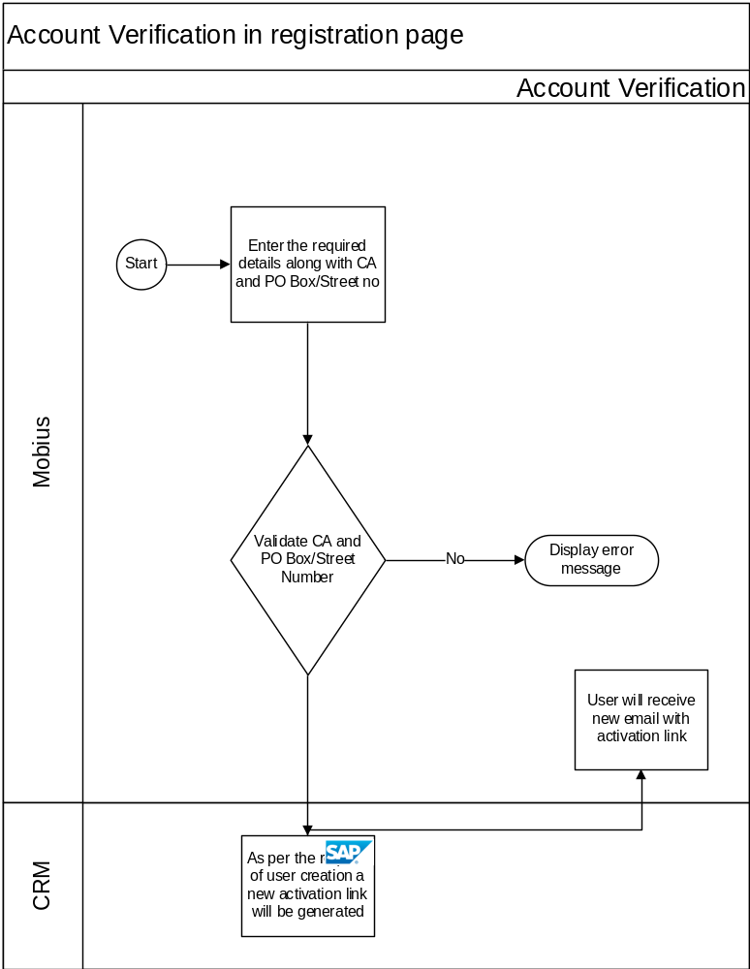

Pseudo code
- Changes in the enhancement implementation ZZCRM_IU_UMC_URM of BADI Implementation ZZCRM_IU_UMC_URM_VERIFICATION.
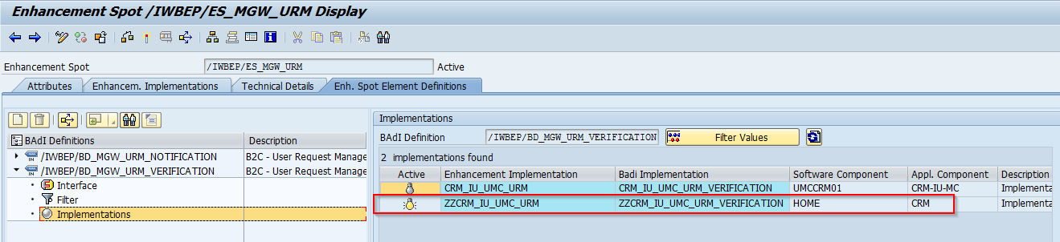
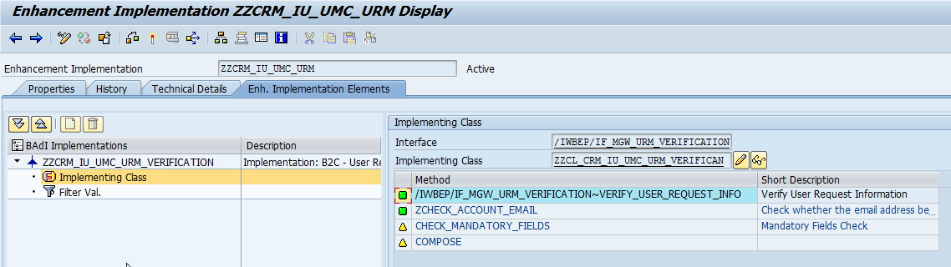

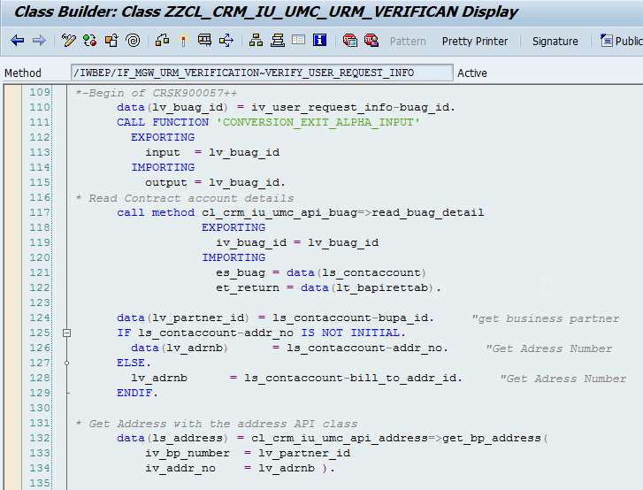

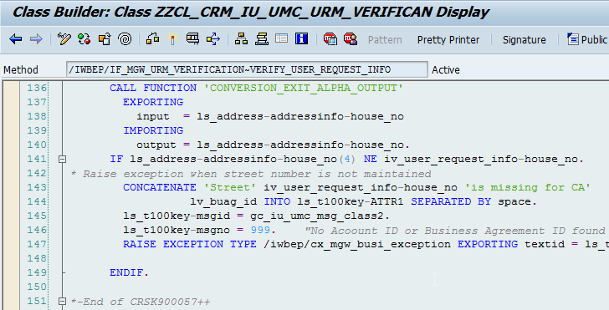

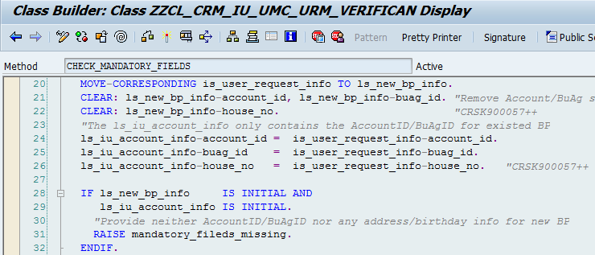

- New Message number 999 created for Message Class -> ZCRM_IU_UMC_ODATA
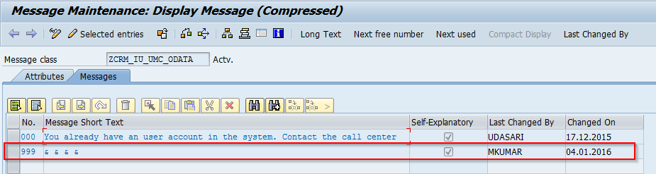

BADI/Enhancement Description

BADI Definition | Implementation name | Methods | Comments
/IWBEP/ES_MGW_URM | ZZCRM_IU_UMC_URM_VERIFICATION | /IWBEP/IF_MGW_URM_VERIFICATION~VERIFY_USER_REQUEST_INFO | This method need to Implement in CRM

Enhancement | Main Program | Includes | Form Routines

Custom Tables/Structure in SAP
N/A

Structure Name
Short text
Size category
Table maintenance allowed
Data class
Buffering
Table maintenance generation
Authorization Group
Field Name | Data Element | Domain | Type | Length | Check Table-Field | Key Field | Foreign Key | Description
Comments

Error Handling

--N/A--

Error Messages
Describe the expected error messages for different error conditions.

Error Message Number | Error Message Text (70 characters) | Error Conditions
ZCRM_IU_UMC_ODATA(999) | String regarding PO Box and Street Number validation | Validate PO Box or Street Number of Mailing address of CA

Security Requirements/ Authorization Details

--N/A--

Unit Test Plan

Refer to project test plan

